Photocatalytic NO_{x} removal with TiO₂-impregnated 3D-printed PET supports
G. F. Binetti Basterrechea¹, V. N. Montesinos^{1,2*}, N. Quici^{1,2*}.
(1) Centro Tecnologías Químicas – Dpto. de Ingeniería Química, FRBA, UTN, Medrano 951, Ciudad Autónoma de Buenos Aires, Argentina.
(2) Gerencia de Química – CNEA, CONICET, Av. Gral. Paz 1499, Villa Maipú, Argentina.
*vnmontesinos@gmail.com
*nataliaquici@gmail.com

Infill Density Selection

The best PET load inside the monolith, i. e., the empty inner volume of each one, was was selected by measuring the UV light transmittance through monoliths of 5, 10, 15, 20 and 30% infill density. Each monolith was placed 2 cm from the UVLED where a reference irradiance of I₀ = 3480 μW/cm² was measured with a Spectroline Model DM-365 XA radiometer. Then, the irradiance of the UV light outcoming the monoliths was measured (Figure S1 a)) was measured and the results are displayed in Figure S1 b). The best infill density was 15%.
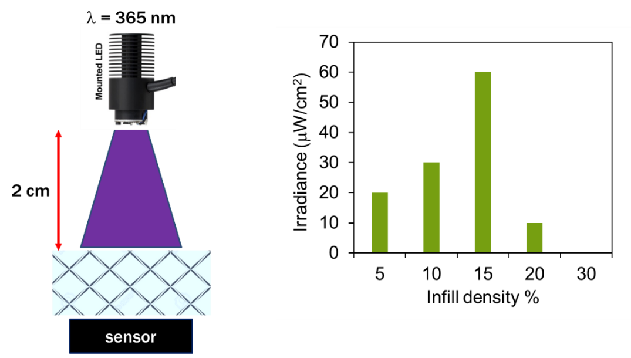
b)
a)

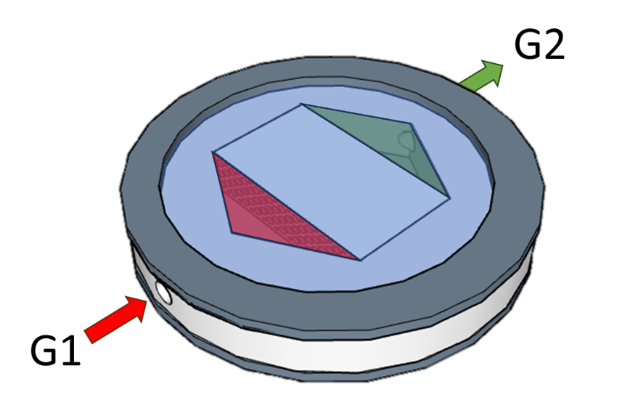  c) | 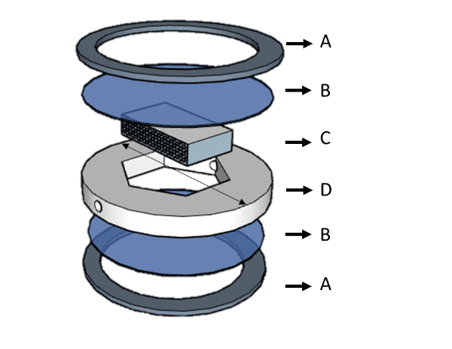  d)
Figure S 1. a) experimental setup for optimal infill density selection; b) irradiance measured after UV-light passed across the monolith; c) gas flow scheme inside the reactor (G1: gas stream 1, NO 40 ppm; G2: gas stream 2, treated NO); d) deconstructed sight of the planar reactor (A: Nylon flange, B: 240 × 6.5 mm Pyrex glass windows; C: 280 × 15 mm Teflon body)
In Figure S1 b a detailed composition of the flat PTFE reactor is shown. The

Effect of the amount of TiO₂ layers
Figure S 2. Net removal of NO and NO_{X} for 1, 2 or 3 TiO₂ layers after each impregnation run and the amount of TiO₂ deposited in each impregnation run. Filament: BPET; TiO₂: P25; UV source: UV-LED

Effect of filament composition

Figure S 3. Net removal of NO and NO_{X} for P25@BPET and P25@PETG under irradiation with the UV-LED and the amount of TiO₂ deposited in each case.

Effect of TiO₂ type
a) | b)
c) | d)

Figure S 4. time resolved profiles of a) NOx, b) NO, c) NO₂ concentration and d) S during the photocatalytic removal of NO.

Table S 1. Relevant characteristics of P25 and UV100 [1].
TiO₂ | Composition | Size (nm) | S.S.A. (g/m²) | Relative surface water (H₂O^{surf}_{UV100}/ H₂O^{surf}_{P25})
P25 | 80% A/20%R | 32 | 49 | 1.57
UV100 | 100% A | 10 | 270
A: anatase; R: rutile

# | TiO₂ layers | PET | Light source | TiO₂ | H₂O | R^{NOx}  (µmol/gTiO₂) | R^{NO}  (µmol/gTiO₂) | S(%) | R^{DeNOX}
1 | 1 | BPET | UVLED | P25 | No | 38.8 ± 5.6 | 51.4 ± 9.1 | 71.0 ± 2.2 | 7.1
2 | 2 | BPET | UVLED | P25 | No | 29.8 ± 7.4 | 32.4 ± 8.7 | 86.7 ± 1.9 | 20.6
3 | 3 | BPET | UVLED | P25 | No | 27.3 ± 4.0 | 32.8 ± 2.7 | 77.8 ± 4.9 | 11.7
4 | 1 | PETG | UVLED | P25 | No | 95.2 ± 17.2 | 111.8 ± 16.1 | 79.9 ± 2.9 | 47.3
5 | 1 | PETG | BLT | P25 | No | 322.5 ± 18.5 | 334.2 ± 10.9 | 91.1 ± 2.3 | 259.5
6 | 1 | PETG | BLT | UV100 | No | 658.4 ± 64.3 | 1355.6 ± 133.8 | 42.9 ± 4.3 | -1094.2
7 | 1 | PETG | UVLED | P25 | Yes | 218.6 ± 20.7 | 250.5 ± 23.9 | 76.1 ± 7.6 | 81.3
Table S 2. Percentual selectivity, R^{NOx}, R^{NO} and R^{DeNOX} for each NO removal xperiment.

References
[1] A.Y. Nosaka, T. Fujiwara, H. Yagi, H. Akutsu, Y. Nosaka, Characteristics of water adsorbed on TiO2 photocatalytic systems with increasing temperature as studied by solid-state1H NMR Spectroscopy, Journal of Physical Chemistry B. 108 (2004) 9121–9125. https://doi.org/10.1021/jp037297i.

