
(Research Article)
Synthesis and characterization of Co₃O₄ nanoparticles for use as pigments in solar absorbing paints
Gardey Merino María Celeste ^{1, *}, Rodriguez Ibarra Mariana Estela ¹, Lascalea Gustavo Enrique ² and Vázquez Patricia Graciela ³
¹ Grupo CLIOPE, Facultad Regional Mendoza, Universidad Tecnológica Nacional (UTN), Rodríguez 273, (M5502AJE) Mendoza, Argentina.
² LQA – IANIGLA, CCT CONICET Mendoza, Av. Ruiz Leal s/n Parque Gral. San Martin, (M5502IRA) Mendoza, Argentina.
³ Centro de Investigación y Desarrollo en Ciencias Aplicadas “Dr. Juan J. Ronco” (CINDECA), CCT CONICET La Plata, Universidad Nacional de La Plata, 47 N° 257, La Plata (B1900AJK), Buenos Aires, Argentina.
GSC Advanced Engineering and Technology, 2021, XX(XX), XXX–XXX
Publication history: Received on 08 May 2021; revised on 15 June 2021; accepted on 18 June 2021
Article DOI: xxxxxxxxxxxxxxxxxxxxxxxxxxxxxxxxxxx

Abstract
This aim of this research is to produce Co₃O₄ oxide by means of one-step solution novel combustion methods using aspatic acid (C₄H₇NO₄); lysine (C₆H₁₄N₂O₂); tris (hydroximethyl) aminomethane (NH₂C (CH₂OH)₃) and ethylene diamine tetra-acetic acid (C₁₀H₁₆N₂O₈) as fuels. The pigments were characterized using X-ray diffraction, scanning and transmission electron microscopy, infrared spectroscopy with Fourier transform and UV-VIS-IR Spectrophotometry.
The paint based on alkyd resin was made from pigments obtained (Co₃O₄ oxide). In order to make a comparison of the thermal emittance of the paint, two different formulations were prepared and these coating are named "absorbent paint coating": one that included 1% by weight of aluminum in metallic powder and another, with 1% of copper in metallic powder, respectively. The solar absorbance for the Co₃O₄ powders, plus quartz cuvette, gave a value of 0.9 in all cases. An extraordinary value of absorption on the coatings between 95 and 96% was noted. These results suggested that the synthesis of combustion in solution makes it possible to obtain a Co₃O₄ absorbent pigment with different fuels.
These syntheses have a low environmental impact because they are one-step processes. All use low amounts of reactive ash obtained at a calcination of about 500 °C. These results suggest the possibility of utilizing this oxide in absorbent solar paints.
Keywords: Co₃O₄; Nanoparticles; Combustion synthesis; Solar absorption; Solar absorbing paints
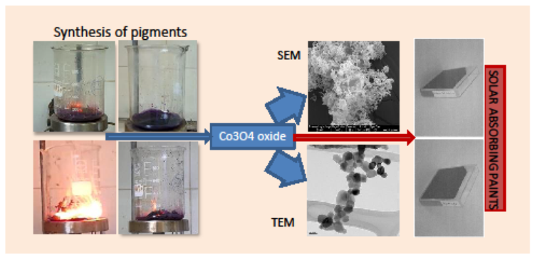

Introduction
The International Energy Agency [1] estimates that the share of renewables in primary energy use will increase. Electricity generation from renewables will approximately triple from 2010 to 2035, attaining 31% of total production. In 2035, hydropower will provide half of renewable production, wind nearly one-quarter and solar PV 7.5%. Solar PV production will increase 26-fold from 2010 to 2035. The use of renewables is expected to reduce CO₂ emissions by over than 4.1 Gt in 2035, contribute to the diversification of the energy sources, reduce oil and gas import bills, and decrease air [2]. In particular, solar energy can be used in industrial, commercial and domestic areas. In domestic applications, households consume energy in air conditioning, heating, water heating, lighting and other applications [3].
In Argentina [4], the average consumption of Sanitary Hot Water (DHW) for a typical family of 3.3 people is about 180 liters of water per day. The energy needed to bring this volume of water from 17 °C to 42 °C (comfort temperature for DHW), requires 5.2 kWh/day (equivalent to 0.5 m³ (GN)/day).
Paradoxically, the conventional DHW equipment in Argentina has consumptions, [5] it arises that a basic requirement for ACS equipment to minimize its energy consumption and GEI emissions, both in its conventional version and solar thermal or other technology, it is crucial that they reduce or eliminate the passive consumption [6]. For example, a hybrid solar thermal equipment in central Argentina can typically provide 65% or 70% of the energy used for DHW.
Solar absorber coatings have attracted a great deal of interest because the efficiency of any solar collector system is strongly dependent on the ability of its absorber to convert solar radiation into heat. The highest photothermal conversion efficiency is to be expected when the coating is able to absorb across most of the solar radiation spectrum (0.3–2.0 μm), giving the coating a high solar absorptance (αs > 0:90) [7].
The selective surfaces used in low-temperature flat solar collectors for domestic water heating can be formed by a metallic substrate (stainless steel, copper, aluminum) with high infrared reflectivity (µ> 3µm) and a paint that It covers with a high absorption in the solar spectrum, that is to say (0.3 µm <µ <3µm), both characteristics give the collector a high energy efficiency.
It has been studied for solar absorbing paints with different pigments, how the concentration to volume of the pigment (PVC) and its thickness influence the transmission and reflection properties; Selective surfaces can also be formed by coatings obtained by methods such as sol-gel [8] and spray pyrolysis [9] where different cobalt oxides have been deposited on stainless steel substrates and have been obtained absorption values of 86% and emittance of 20%.
Co₃O₄ particles have been obtanied by hydrothermal [10] and precipitacion methods [11]. Itteboina and Sau were witnessed many advances in the synthesis and characterization of nonspherical cobalt oxide particles. For example, Hu et al. reported the synthesis of Co₃O₄ particles with different shapes and crystal facets and studied their catalytic properties towards methane combustion reaction [13]. Cao et al. reported the synthesis and studies of catalytic and magnetic properties of porous Co₃O₄ microcubes [14]. Additionally, Xie and Shen synthesized zero-dimensional to hierarchical cobalt oxide nanostructures [15]. By solution combustion syntheses, it is possible to obtain nanoparticles with homogenous crystalline structure by a one step, simple route [16].
The parameters influencing combustion reactions include type of fuel, fuel to oxidizer ratio, use of an excess of oxidizer, ignition temperature and water content of the precursor mixture [17]. The effect of fuel to oxidizer ratio in microstructure was studied in the synthesis of Co₃O₄ using urea as fuel [18] and, the influence of glycine and urea as fuels was studied to obtain Co₃O₄ through stoichiometric combustion syntheses and in studies for optimized combustion reaction to obtain Al₂O₃ with eight different fuels as lysine, glutamine and arginine, etc [19].
This work takes into account that large companies have undertaken an ambitious search betting on innovation and development in order to manufacture products that can be upgradable [20]. That is why we are facing a paradigm shift that has been raised in the face of unresolved issues by the 12 principles of green chemistry, a system known as Circular Economy (CE) [21]. Strictly speaking, the CE seeks to maintain the value of the products, the materials that make them up and the resources with which they were made in order for them to last as long as possible, minimizing the carbon footprint and economic savings [22].
In this work, the use of new fuels such as lysine mono-hydrochloride (LIS), aspartic acid (ASP), ethylene diamine tetra acetic acid (EDTA), and tri-hydroxy-methyl-aminomethane (TRIS) are proposed to obtain Co₃O₄, by stoichiometric combustion synthesis (SCS), to be used as pigments in solar absorbing paints. Once obtained by combustion processes, the ashes were calcined at 500 °C in order to get the pigments with the desired crystalline structure. The powders were characterized by X-Ray Diffraction (XRD), Scanning Electron Microscopy (SEM), and Transmission Electron Microscopy (TEM), Infrared Spectroscopy with Fourier transform (FT-IR) techniques. Then, alkyd-based enamel was prepared with the pigment obtained through Asp-based process; the so-prepared enamel was then applied on galvanized steel plates. The spectral absorbance plots of those substrates were determined for the solar spectrum range of radiation.

Material and methods

Synthesis of pigments
All reagents used were Aldrich pro-analysis grade.
The Co₃O₄ pigments were obtained from Co (NO₃)₂.6H₂O and the fuel chosen in each case was: ASP (C₄H₇NO₄); LIS (C₆H₁₄N₂O₂); TRIS (NH₂C (CH₂OH)₃) and EDTA (C₁₀H₁₆N₂O₈), respectively. The precursor solution was prepared from 5 g of Co salt, the corresponding stoichiometric amount of fuel and distilled water. The solution has a pH value that depends on fuel used; in all cases it was placed to concentrate on a heating plate at 250 °C. Once the ashes were obtained, they were placed for 1 h in an oven at 200 °C to complete the reaction and, finally, in an air oven at 500 °C for 2 h, for subsequent calcination. The objective is to eliminate carbonaceous residues and obtain the desired crystalline phase, Co₃O₄.
Table 1 indicates the amount of fuel used, the pH of the precursor solution and the end of combustion for each fuel used together with the nomenclature of the samples obtained. In Figure 1, digital photographs of the moment of combustion of each of the syntheses are observed.
Table 1 Synthesis variables for the different samples
Combustible | Amount of fuel used [g] | pH precursor solution | Combustion | Denomination of pigments
ASP | 1.37 | 3 | With spark and flame | Co₃O₄-ASP
EDTA | 1.13 | 2 | No spark and flame | Co₃O₄-LIS
LIS | 0.83 | 3 | With spark and flame | Co₃O₄-EDTA
TRIS | 0.89 | 7 | No spark and flame | Co₃O₄-TRIS

To determine the mole fuel/mole Co ratio, the following stoichiometric reactions were postulated for each fuel:

For syntheses using ASP:
10 Co(NO₃)₂.6H₂O + 6 C₄H₇NO₄ → 5 Co₂O₃ + 24 CO₂ + 81 H₂O + 3 N₂ (1)
For syntheses using EDTA:
40 Co(NO₃)₂.6H₂O + 9 C₁₀H₁₆N₂O₈ → 20 Co₂O₃ + 90 CO₂ + 312 H₂O + 49 N₂ (2)
For syntheses using LIS:
34 Co(NO₃)₂.6H₂O + 9 C₆H₁₄N₂O₂ → 17 Co₂O₃ + 54 CO₂ + 267 H₂O+ 43 N₂ (3)
For syntheses using TRIS:
14 Co( NO₃)₂.6H₂O + 6 NH₂C(CH₂OH)₃ → 7 Co₂O₃+ 24 CO₂+ 117 H₂O +17 N₂ (4)
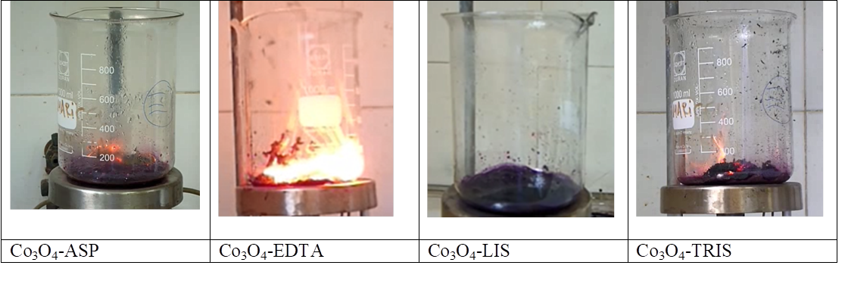
Figure 1 Digital photographs of the syntheses

Pigment characterization
The powders obtained were characterized by XRD, using a Philips equipment model PW-1714 with a built-in scanning graphical recorder, Cu Kα radiation (λ = 1.5417 Å), nickel filter, 30 mA and 40 kV in the high voltage source, with a step of 0.02º, between 30° and 70°. For each fuel are working at varying sweep. In addition, the crystallite size was determined from the diffraction patterns obtained with a Rigaku equipment model D-MAX IIIC, Cu Kα radiation (λ = 1.5417 Å), nickel filter, 30 mA and 35 kV at the source of high voltage with a step of 0.02º, between 35 and 40º, at a scanning speed of 0.1º/min, analysing the peak [311] located at a value of 2θ = 36.9º approx., and it was calculated using Scherer's formula [23]. The shape and size of the particles were observed through the Transmission Electron Microscopy (TEM) technique was used with a JEOL Electron Microscope, model 100 CX II using a voltage of 100 kV. On the grid sample holder, a film of cellulose acetate/butyrate dissolved in ethyl acetate was placed, and glycerine drops were placed to form holes. Finally, a carbon film was placed to increase the resistance.
The morphology of the powders was observed through a Scanning Electron Microscopy (SEM) with a JEOL, model 6610 LV microscope.
Bruker IFS 66 equipment, pellets with BrK, and a measuring range of 400-1500 cm⁻¹ were used to obtain the FT-IR spectra of the solid samples.
The measurements of the optical transmission and reflection characteristics of the specimens in the spectral range of solar radiation (0.3 µm <µ <3 µm) were carried out with a SHIMADZU model UV-3101PC double beam spectrophotometer. With integrating sphere model ISR 3100, using normal/hemispherical geometry, with specular component included. The measurements were made by placing the pigments in a quartz cuvette and not directly, because the powders could not be compacted sufficiently to prevent them from detaching and contaminating the integrating sphere. In Figure 2 the samples contained in the quartz cuvettes are observed, as they were measured in the spectrophotometer. The absorption measurements in the solar spectrum on the powders were carried out in order to have a reference of this property before manufacturing the paints and to detect if the fuel used in the synthesis has any kind of influence on the absorption values obtained. From the values of the spectral characteristics, the following integral characteristics were calculated:
Solar transmittance (τ_{S})
Whereτ_{λ} is the spectral transmittance of the sample between 300 nm and 2500 nm; S_{λ} is the normalized relative spectral distribution of global solar radiation for air mass = 1.5 (this value is specified by ISO 9845-1: 1992 (en) Solar energy - Reference solar spectral irradiance at the ground at different receiving conditions - Part 1: Direct normal and hemispherical solar irradiance for air mass 1.5) [24] and Δλ is the interval between wavelengths.
Solar reflectance (ρ_{S}):
Where ρ_{λ} is the spectral reflectance of the specimen between 300 nm and 2500 nm; the solar absorbance (α_{S}) results from the following formula:
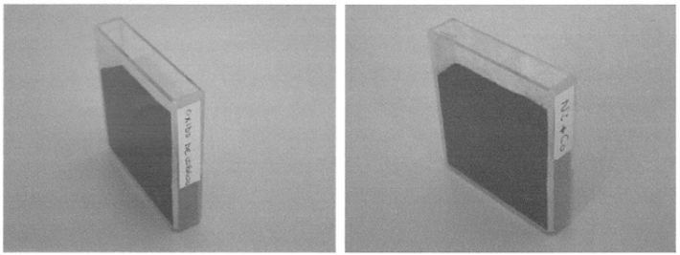
Figure 2 Co₃O₄ samples inside a quartz box prepared to measure its optical properties. On the left, Co₃O₄-LIS and on the right Co₃O₄-ASP

Synthesis of paintings
The paint based on alkyd resin to be studied was made from pigments obtained with aspartic (Co₃O₄-Asp), explanation in results. Solid ingredients were mixed in a ball mill and then solvents were added. In order to make a comparison of the thermal emittance of the paint, two different formulations were prepared and these coating are named "absorbent paint coating": one that included 1% by weight of aluminium in metallic powder (Paint-Al) and another, with 1% of copper in metallic powder (Paint-Cu), respectively. Galvanized steel plates measuring 30 x 15 cm were painted, with both paints, with a brush. Previously, the plates were subjected to a treatment with phosphoric acid so that the surface achieves porosity and the paint a better adhesion. In Figure 3 there are digital photographs of the surfaces painted with the paints obtained.
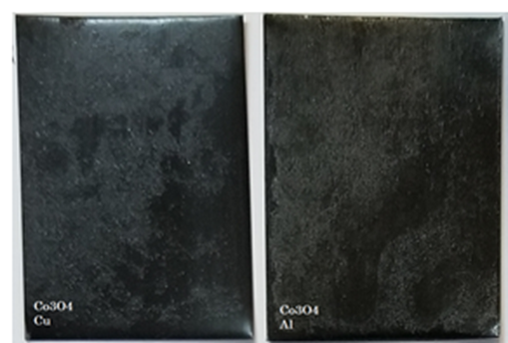
Figure 3 Digital photographs of the surfaces painted with the paints obtained

Characterization of the paintings
The solar absorbance was determined from the reflectance measurements of the test tubes in the spectral range of solar radiation, they were carried out with the same spectrometer and sphere used for the pigments. From the spectral reflectance values, the solar absorbance was calculated.
The dry paint thickness was determined using Elcometer brand equipment, model 456B, FNF meter whose operating principle is by magnetic induction. 10 different points were measured on each sample and the reverse of the plate was taken as "zero". Average of measurements is reported in Table 3.

Results and discussion
In the synthesis by combustion from a precursor aqueous solution where a reducing substance, an oxidant and a precursor of the metal of interest are mixed. Then there is a critical concentration by evaporation, a highly exothermic redox (reduction-oxidation) reaction. The combustion that results in ashes, collected and suitably calcined, generates the desired oxide. Combustion syntheses are characterized by high temperatures, fast heating rates, and short reaction times; it is due to the generation of high temperatures, in a short time, that the resulting crystalline phases are capable of forming a large number of nuclei, but these cannot grow significantly, allowing the obtaining of nanostructured phases [25]. The mechanism of a combustion reaction is extremely complex. Among the parameters that have the greatest influence are: the type of fuel, the reducing agent-oxidant ratio, the use of excess oxidant, the ignition temperature and the critical water content remaining in the precursor mixture in the gel that enters the ignition [26].
For all samples obtained, the face-centered cubic phase, spinel type of the Co₃O₄ corresponding to JCPDS No. 421467 was observed. In Figure 4 the diffraction patterns of both samples are observed, identifying the peaks according to the Miller indices of the corresponding plane. The crystallite size for each of the samples in increasing order was 19 nm for the sample synthesized with LIS, 29 nm with ASP, 33 nm with TRIS, and 43 nm with EDTA.
The pigments obtained, at 500 ° C, with different fuels have the same spinel-type crystalline structure, but differ in the crystallite size reached in each case; which may be due to the heat released during combustion. In particular, for the Co₃O₄-LIS pigment, the smallest size was obtained and coincides with a combustion reaction without spark and flame, producing less crystallite growth. Toniolo et al. [26] carried out synthesis by combustion of cobalt oxides using glycine or urea as fuels and in different fuel-oxidant ratios and observed that the metallic Co powder was formed only in fuel-rich reactions with glycine, while the cobaltous oxide phase was formed in fuel rich reactions of both fuels. This difference may be attributed to the chemical nature of the fuels at a smaller crystallite size there is an increase in the optical absorption band of the oxide [27].

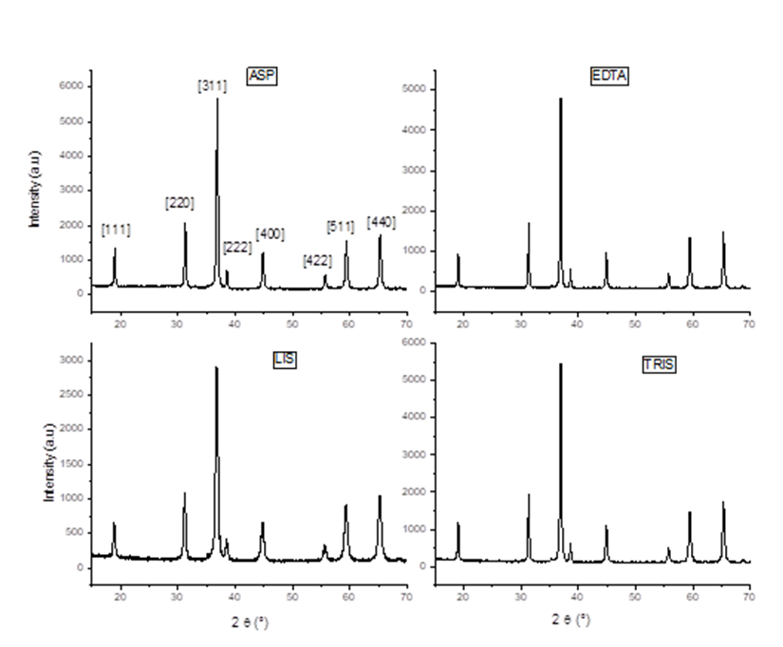
Figure 4 DRX diffraction patterns of pigments calcined at 500 °C
The TEM micrographs are seen in Figure 5. An average particle size of approximately 50 nm is observed, with a polyhedral shape. According to Chen et al. the Co₃O₄ nanowires obtained by green synthesis method and the wire was composed of numerous interconnected nanoparticles with size of 10–20 nm. Nanowires were obtained by a precursor via solution process and subsequent thermal descomposition of the precursors at atmospheric pressure. The shape of final product can be controlled by amount of initial cobalt salt [28].
The SEM micrographs of the samples are observed in Figure 6. In all the synthesized samples an agglomeration of particles with size of the nanometric order is observed. These particles united in a kind of network resulting from the combustion process. In particular, in the case of the Co₃O₄-LIS sample, it presents greater agglomeration when the combustion process was smoother, without spark and flame, unlike the rest of the pigments, where a more open structure resulting from processes with spark and flame is observed. The surface morphologies observed by SEM for the different fuels in obtaining Co₃O₄ is very diverse and depends on the type of synthesis. For example, in Co₃O₄ sol-gel synthesis, the precursors, particularly the nature of the anionic part of the salt, played key roles in determining the size and morphology of the particles.
Solvents and capping agents also influenced the particle morphology; however, they had significant impacts on the particle size and other microstructural features [12].

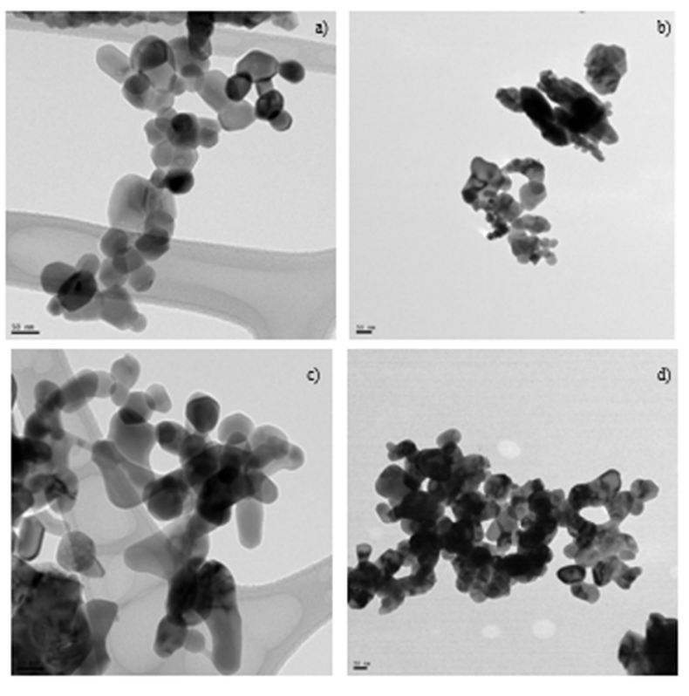
Figure 5 TEM Micrographs of pigments calcined at 500 °C. a) Co₃O₄-ASP, b) Co₃O₄-EDTA, c) Co₃O₄-LIS y d) Co₃O₄-TRIS

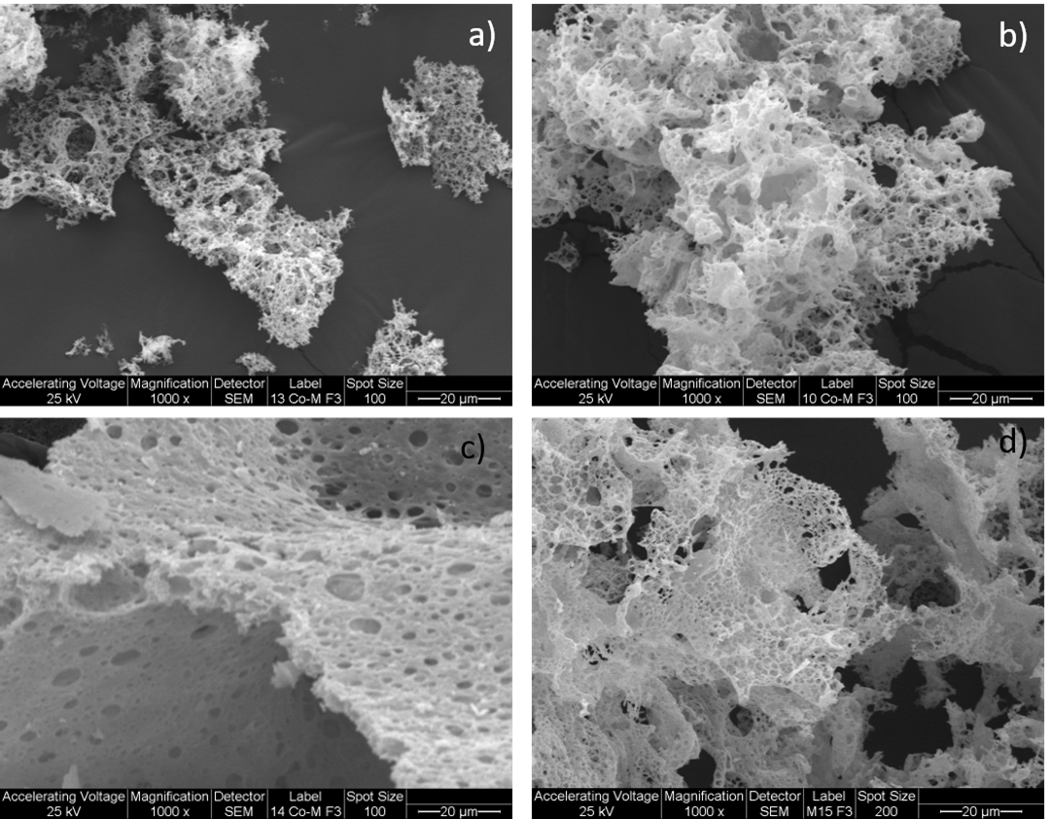
Figure 6 SEM Micrographs of pigments calcined at 500 °C. a) Co₃O₄-ASP, b) Co₃O₄-EDTA, c) Co₃O₄-LIS and d) Co₃O₄-TRIS

Figure 7 shows the FT-IR obtained from each sample. In the one corresponding to the Co₃O₄-TRIS sample, two different bands are observed at (ν1) 578 and (ν2) 658cm⁻¹ that would be caused by the vibrations caused by the extension of the metal-oxygen bonds, which is coherent and confirms the obtaining of a Co₃O₄ with a spinel-like structure [29]. The same bands are observed for the rest of the pigments. The ν1 band is characteristic of the vibration of Co⁺³ at the octahedral site and the ν2 is attributed to the vibration of Co⁺² at tetrahedral sites in the spinel lattice. The widest bands at 3450 and 1660 cm⁻¹ are due to vibration related to the extension of the O-H bond through the H bonds corresponding to water [30].
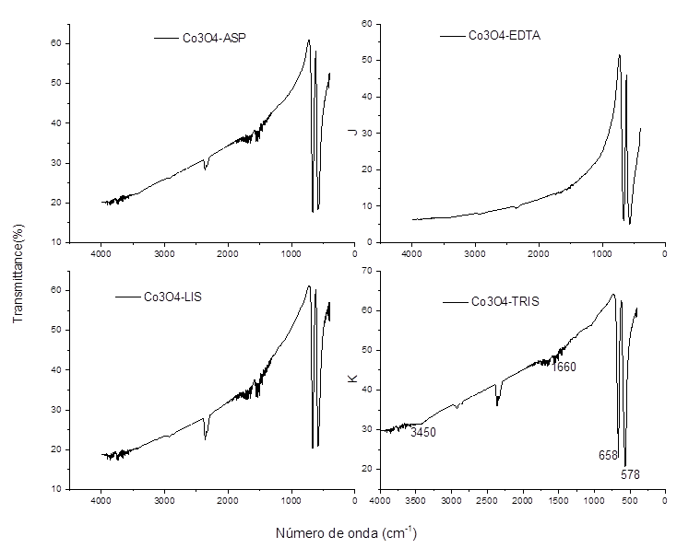
Figure 7 FT-IR of the pigments obtained calcined at 500 °C
The important physical-optical properties of pigments are their light absorption and scattering properties that depend upon the wavelength, particle size, particle shape and refractive index. Thus, for coloured pigments; the optimum particle size should be 1-10 μm and they should possess high refractive index. to give good tinctorial strength (ability of a colourant to impart colour) Oxide materials like alumina, aluminates, silicates, borates, zirconia and zircons doped with transition metal or rare earth ions meet these requirements of ceramic colourants. Of these, the cobalt pigments are of paramount importance in ceramic industry due to their spectacular variety of colours high tinting strength and remarkable stability under chemical, thermal and reducing conditions [31].
For the solar selective pigments, spinel structured ceramic/ metal nanoparticles are chosen as excellent material. These spinels have the formula of AB₂O₄, where A and B are typically transition metals with partially filled d orbitals such as manganese, cobalt, iron, and chromium. Materials with this crystal structure are well-known for its temperature durability and oxidation stability [32].
Recently were studied CoCuMnOx [33] and CuCrMnO4 [32] as pigments for spectrally selective paints. In particular, cobalt spinels have been obtained by precipitation methods as pigment for absorbing solar paints [34]. Actually, has been reported the employing of CoO and Co₃O₄ as pigments for solar selective surfaces in CSP (concentrating solar power) systems [35].
In relation with optical properties, the transmittance of both Co₃O₄-ASP (corresponding to Co₃O₄-ES-Asp in figure 8 and 9, “ES” is Stoichiometric) and Co₃O₄-LIS(corresponding to Co₃O₄-ES-Lis in figure 8 and 9, “ES” is Stoichiometric) is equal to zero throughout the spectral range. In Figure 8 the spectral reflectance curves of both samples are between reflectance values of 0.1 and 0.3, approximately, the Co₃O₄-ASP values are higher than those of the Co₃O₄-LIS sample.
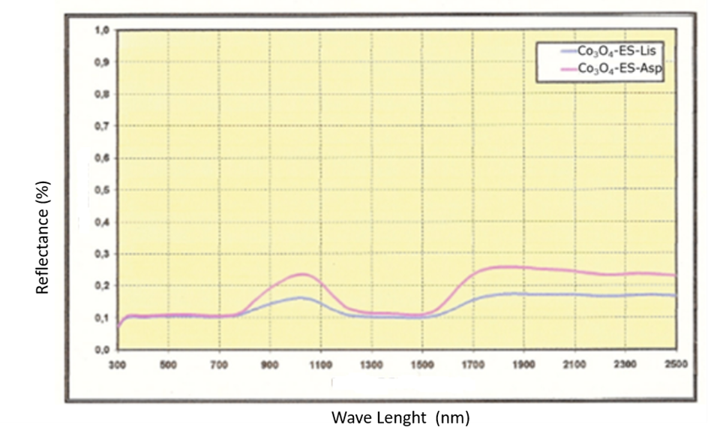
Figure 8 Spectral reflectance values in the solar range for the samples Co₃O₄-ES-ASP (red) and Co₃O₄-ES-LIS (blue)
Figure 9 shows the curves obtained for the spectral absorbance for the samples studied; these are located between values of 0.7 to 0.9, approximately. For the case of the Co₃O₄-LIS sample, higher values are observed than for the Co₃O₄-ASP.
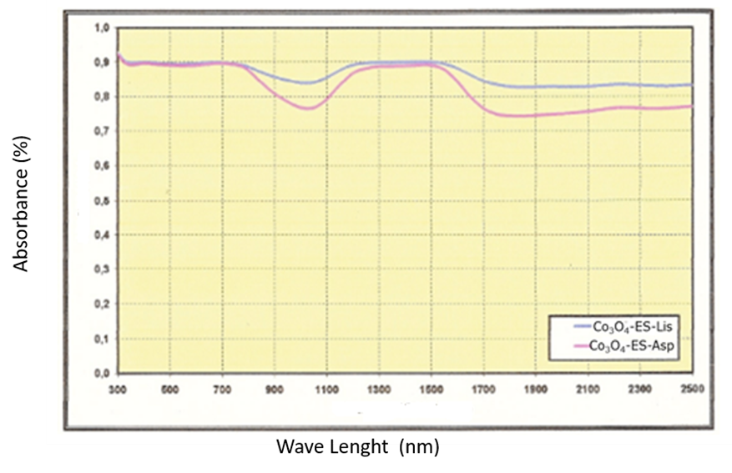
Figure 9 Spectral absorbance values in the solar range for the samples Co₃O₄-ES-Asp (red) and Co₃O₄-ES-Lis (blue).
Table 2 shows the values corresponding to the reflectance and solar absorbance of both samples. Resultando valores de ρs ~0,1 para ambos pigmentos y de αs ~0,9.
Table 2 Optical property values of the two samples
Sample | ρ_{s} | α_{s}
Co₃O₄-LIS | 0.11±0.05 | 0.89 ±0.05
Co₃O₄-ASP | 0.13±0.05 | 0.87 ±0.05

These values were obtained as an average of ten different measurements on each specimen, with a standard deviation between measurements of 0.0011. The results obtained show that there is a slight variation in the absorption values according to the fuel used. These synthesized samples demonstrate their ability to be used in solar absorbing paints because their solar absorption values are close to 0.88-0.94. These values are measured for selective surfaces, synthesized from paints composed of Co₃O₄ pigments, applied on aluminium sheets, in US patent 4310596 [34]. Additionally, the spinel copper chromite was doped with diﬀerent elements (Zn, Al, Sn, Ni, Co, and Mn) to improve the solar absorbance and a solar absorbance value of 0.98±0,05 was obtained for the pigment based on spinel CuCrMnO₄ [33].
Since both pigments resulted in high absorption values, Co₃O₄-ASP was selected. Table 3 shows the absorption values of both absorbent surfaces, where the Cu base paint (Paint-Cu) resulted with a spectral absorbance value of 96% slightly higher than that of the Al base paints (Paint-Al) with a value of 95%.
Table 3 Solar absorption and thickness of the paints applied on metal surfaces
Sample | Solar Absorbance  α_{s} (%) | Average thickness (μm)
Paint-Cu | 96 ±0.5 | 33 ± 1
Paint-Al | 95±0.5 | 31 ± 1

This difference could be due to the difference in thickness observed in the Cu base paint of greater than approx. 33 μm slightly larger than the other painting, 31 μm. Figure 10 shows the spectral absorbance of the painted surfaces between wavelengths of 250 to 2500 nm. In addition, it is observed that the curve of the Cu base paint (Paint-Cu) presents higher absorbance values compared to the base paint Al (Paint-Al). In other words, the use of metallic Cu powder in the formulation of the paint significantly increases the solar absorbance compared to metallic aluminum.
Selective surfaces formed by polymeric coatings with acrylic resin and Co₃O₄ pigments on a fine metallic aluminum substrate showed a solar absorbance of 94% and a film thickness of 7 mm obtained by spin-coating techniques [34]. The coating layers consist of or includes cobalt oxide nanopowders (CoO and Co₃O₄) were dispersed in silica matrix, and deposited on metal substrates via a simple and scalable spray coating process, which is compatible with CSP applications. Finally, the developed coating layer exhibited unprecedented high-temperature durability, showing no degradation in structural or optical, FOM (Figures of merits) between 0,85 and 0,89 were obtained [35].
The high solar absorption of paints based on Co₃O₄ obtained in this research are important evidences for its ability to improve energy efficiency of low temperature solar collectors additionally in accord with recently published patents [35]. Co₃O₄ pigments can be part of the receiver coating in the next generation CSP (concentrating solar power) systems should possess not only high thermal efficiency but also high temperature stability because of the anticipated trend of higher operating temperature (above 700-750 °C). Co₃O₄ black oxide (incorporated in light absorbing coating) is a promising solar absorption candidate material for 750 °C in CSP operating environment.

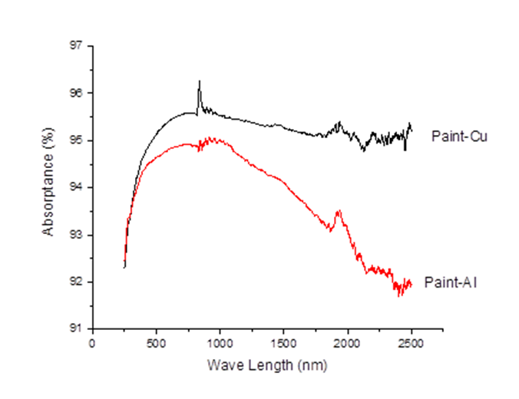
Figure 10 Spectral Absorptance (%) of painted surfaces

Conclusion
By solution combustion syntheses, it is possible to obtain nanoparticles with homogenous crystalline structure by a one step, simple route. Co₃O₄ powders were obtained using four fuels for which an average particle size of 50 nm was obtained in a polyhedral shape. The optical properties of the Co₃O₄ powders in a quartz cuvette were determined and the results obtained do not show a determining variation when the fuel is changed.
On the other hand, the high cost and environmental impact associated with thermoelectric energy motivated the development of materials that improve the performance of water heaters, refrigerators and other solar devices. Even more so in areas far from basic services where the incorporation of devices for alternative energy can improve the quality of life of the inhabitants. Hence the circular economy is an economic concept that is interrelated with sustainability, and whose objective is that the value of products, materials and resources such as energy is maintained in the economy for as long as possible, and that it is reduced the generation of waste to a minimum. It is about implementing a new, circular -not linear- economy, based on the principle of "closing the life cycle" of products, services, waste, materials and energy.

Compliance with ethical standards
Acknowledgments
The authors thank Cintia Quiroga from INTI-Procesos Superficiales, Buenos Aires (Argentina) for the measurements of the optical properties of pigments and paints, and Mateo Paez from CIDEPINT, La Plata, (Argentina) for the formulation of absorbent paints.
Disclosure of conflict of interest
The authors have no conflict of interest in this research study.

References
- Hoeven, M. International Energy Agency. World energy outlook. 2012.
- Mehdi J, Youssef BS. Output, renewable and non-renewable energy consumption and international trade: Evidence from a panel of 69 countries. Renewable Energy. 2015; 83(C): 799-808.
- Al-Khaffajy M, Mossad R. Optimization of the heat exchanger in a flat plate indirect heating integrated collector storage solar water heating system. Renewable Energy. 2013; 57: 413-421.
- Iannelli LM. Efficiency in the heating of sanitary water for the residencial use in Argentina. Master thesis, CERARE Buenos Aires University, Argentina. 2019; 143-147.
- Iannelli LM, Gil S. Hot sanitary water in Argentina. ¿Which are the most convenients options? Technical Report. 2020.
- Iannelli LM. Efficiency in the heating of water. Passive consumption in conventional and hybrid solar systems. PETROTECNIA. 2016; 3: 585-595.
- Niklasson GA, Granqvist CG. Selectively solar-absorbing surface coatings: optical properties and degradation, in: C.G. Granqvist (Ed.), Materials Science for Solar Energy Conversion Systems, in: A.A.M. Sayigh (Ed.), Renewable Energy Series, Pergamon Press, Oxford. 1991; 70–105.
- Barrera E, Huerta L, Muhl S, Avila A. Synthesis of black cobalt and tin oxide films by the sol–gel process: surface and optical properties. Solar Energy Materials & Solar Cells. 2005; 88: 179–186.
- Avila GA, Barrera CE, Huerta AL, Muhl S. Cobalt oxide ﬁlms for solar selective surfaces, obtained by spray pyrolisis. Solar Energy Materials & Solar Cells. 2004; 82: 269–278.
- Jiang Y, Wu Y, Xie B, Xie Y, Qian Y. Moderate temperature synthesis of nanocrystalline Co₃O₄ via gel hydrothermal oxidation. Materials Chemistry and Physics. 2002; 74: 234–237.
- Furlanetto G. Precipitation of spherical Co₃O₄ particles. Journal of colour and Interface Science. 1995; 170: 169-175.
- Ramakrishna I, Tapan KS. Sol-gel synthesis and characterizations of morphologycontrolled Co₃O₄ particle. Materials Today: Proceedings. 2019; 9: 458–467.
- Hu L, Peng Q, Li Y. Selective Synthesis of Co₃O₄ Nanocrystal with Different Shape and Crystal Plane Effect on Catalytic Property for Methane Combustion. Journal of American. Chemical Society. 2008; 130: 16136–16137.
- Cao F, Wang D, Deng R, Tang J, Song S, Lei Y, Wang S, Su S, Yang X, Zhang H. Porous Co₃O₄ microcubes: hydrothermal synthesis, catalytic and magnetic properties Crystal Engineering Community. 2011; 13: 2123–2129.
- Xie X, Shen W. Morphology control of cobalt oxide nanocrystals for promoting their catalytic performance Nanoscale. 2009; 1: 50–60.
- Gardey Merino MC, Alonso JA, Lascalea GE, Vazquez P. Synthesis of CoCuMnOx Pigments for Solar Collectors Absorbent Enamels. Academia Journal of Scientific Research. 2016; 4(10): 316-326.
- Toniolo JC, Lima MD, Takimi AS, Bergmann CP. The effect of fuel to oxidizer ratio in microstructure was studied in the synthesis of Co₃O₄ using urea as fuel. Materials Research Bulletin. 2005; 40: 561–571.
- Venkateswara RK, Sunandana CS. Co₃O₄ nanoparticles by chemical combustion: Effect of fuel to oxidizer ratio on structure, microstructure and EPRSolid State Communications. 2008; 148: 32–37.
- Toniolo JC, Takimi AS Bergmann CP. Nanostructured cobalt oxides (Co₃O₄ and CoO) and metallic Co powders synthesized by the solution combustion method Materials Research Bulletin. 2010; 45: 672-676.
- Kümmerer K. Rethinking chemistry for a circular economy. Science. 2020; 367 (6476): 369-370.
- Zuin VG. Circularity in green chemical products, processes and services: Innovative routes based on integrated eco-design and solution systems. Current Opinion in Green and Sustainable Chemistry. 2016; 2: 40-44.
- Venkata Mohan S. Waste biorefinery models towards sustainable circular bioeconomy: Critical review and future perspectives. Bioresource Technology. 2016; 215: 2–12.
- Klug H, Alexander L. X-ray Diffraction Procedures for Polycrystalline and Amorphous Materials, 2º edition, John Wiley and Sons, New York. 1974; 105-120.
- Chandrasekare, ME. ISO 9845-1:1992 Solar energy — Reference solar spectral irradiance at the ground at different receiving conditions — Part 1: Direct normal and hemispherical solar irradiance for air mass 1,5. 1992. 1-14.
- Bhaduri S, Zhou E, Bhaduri SB. Auto ignition processing of nanocrystalline a-Al2O3. Nanostructured Materials. 1996; 7 (5): 487–496.
- Toniolo J, Takimi A, Bergmann C. Nanostructured cobalt oxides (Co₃O₄ and CoO) and metallic Co powders synthesized by the solution combustion method. Materials Research Bulletin. 2012; 45: 672–676.
- Gu F, Li C, Hu Y, Zhang L. Synthesis and optical characterization of Co₃O₄ nanocrystals. Journal of Crystal Growth. 2007; 304: 369–373.
- Chen H, Wang Y, Xu C. Facile and green synthesis of mesoporous Co₃O₄ nanowires. Materials Letters. 2016; 163: 72–75.
- Ozkay T, Baykal A, Toprak MS, Koseoğlu Y, Durmus Z. Reflux synthesis of Co₃O₄ nanoparticles and its magnetic characterization. Journal of Magnetism and Magnetic Materials. 2009; 321: 2145–2149.
- Al-Tuwirqi R, Al-Ghamdia AA, Aal NA, Umar A, Mahmoud WE. Facile synthesis and optical properties of Co₃O₄ nanostructures by the microwave route. Superlattices and Microstructures. 2011; 49: 416–421.
- Youn Y, Miller J , New K, Hwang KJ, Choi C, Kim Y ,Jin S. Effects of Metal Dopings on CuCr2O4 Pigment for Use in Concentrated Solar Power Solar Selective Coatings. ACS Appl. Energy Mater. 2019; 2: 882−888.
- Geng Q, Zhao X, Gao X, Liu G. Sol–gel combustion-derived CoCuMnOx spinels as pigment for spectrally selective paints. Journal of the American Ceramic Society. 2011; 94(3): 827–832.
- Buskirk V. Solar selective surfaces. US Patent No. 1982; 4: 310-596.
- Sungho J, Renkun C, Zhaowei L, Jaeyun M, Tae KK, La J. Solar energy absorbing coatings and methods of fabrication. U.S. Patent No. 2007; 00735.30A1.

